Ans 1 – Margins in excel are refer as the empty spaces or gap between the Worksheet data and left, right, top and bottom edges of the printed worksheet page through which we can add more or less spaces. We can access this option by going to PAGE LAYOUT tab > Margin icon > Click on the dropdown to use the desired option.

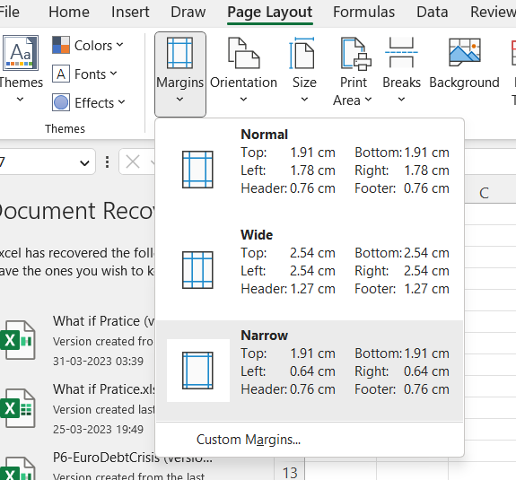

There are different types of margins available i.e;

1. Normal Margin
2. Narrow Margin
3. Wider Margin

All of the above 3 has pre-defined margins settings which are available to use but if we want to have a custom margin setting we can again go to PAGE LAYOUT tab > Margin icon > Click on the dropdown > CUSTOM Margin option and specify the values which we want to give for header and footer or for the top/left/right/bottom edges. After setting the custom margin we can use the same setting again and again and don’t have to change the custom settings.

Ans 2 – 

Ans 3 – Freeze panes is a command/function which helps us to freeze/lock the column and row so that if we have to move to a certain column or a row which has a higher cell reference then also we can see the column headers to match the data for that particular cell.

Example- there is a data available with 100 rows and 7 column headers, then if we try to move to row 80 the column header will not be visible as Headers are available in Row 1, in this situation we can use Freeze Panes to lock the Column header.

Ans 4 - The Freeze Panes command in Excel allows you to keep specific rows and columns visible as you scroll through a large dataset. The different features available within this command are:

Freeze Top Row: This option allows you to keep the top row of your dataset visible as you scroll down.

Freeze First Column: This option allows you to keep the first column of your dataset visible as you scroll to the right.

Freeze Panes: This option allows you to freeze both rows and columns at the same time. You can select a cell below and to the right of the rows and columns that you want to freeze.

Unfreeze Panes: This option allows you to remove the frozen rows and columns and return to the normal view of your dataset.

By using these options, you can customize which rows and columns you want to keep visible as you work with your data, making it easier to navigate and analyze your information.

Ans 5 - Here are some of the different sheet options in Excel and what they do:

Sheet Name: Each sheet within an Excel workbook is identified by a name, which appears on a tab at the bottom of the screen. Sheet names can be changed by right-clicking on the tab and selecting "Rename".

Insert New Sheet: This option allows you to add a new sheet to your workbook. You can choose whether to add a blank sheet or use a template.

Move or Copy Sheet: This option allows you to move or copy a sheet to a different location within the same workbook or to a different workbook altogether.

Delete Sheet: This option allows you to delete a sheet from your workbook. Before deleting a sheet, you will be prompted to confirm the action.

Hide Sheet: This option allows you to hide a sheet from view without deleting it. To unhide a sheet, right-click on any sheet tab and select "Unhide".

Protect Sheet: This option allows you to protect a sheet from being modified by others. You can set a password to prevent unauthorized changes.

Tab Color: This option allows you to change the color of the sheet tab to help you identify sheets more easily.

In summary, Excel sheet options give you a lot of flexibility in terms of how you organize and work with your data. By using different sheets, you can keep related data together, and by using options like Protect Sheet and Tab Color, you can help ensure that your data stays organized and secure.